Azure HDInsight - Basics of Data Science using Apache Spark on Azure HDInsight

## Overview

Azure HDInsight is the only fully-managed cloud Apache Hadoop offering that gives you optimized open-source analytic clusters for Spark, Hive, MapReduce, HBase, Storm, Kafka, and Microsoft R Server backed by a 99.9% SLA. Deploy these big data technologies and ISV applications as managed clusters with enterprise-level security and monitoring.

This lab specifically focuses on Spark ML component of Spark and highlights its value proposition in the Apache Spark Big Data processing framework.

This hands-on lab will step you through the following features:

1. **Notebook** – Connect to a Notebook and run the notebook
2. **Basics of Spark** – Use Python to analyze data using Spark
3. **Basics of Machine Learning –** This notebook demonstrates how to use MLLib, Sparks's built-in machine learning libraries, to perform a simple prediction on an open dataset.

### About the code

## Learn the basics of data science using Spark

This notebook demonstrates how to use MLLib, Sparks's built-in machine learning libraries, to perform a simple prediction on an open dataset.

Launch Jupyter Notebooks https://<Fill_ME_IN>.azurehdinsight.net/jupyter/tree/PySpark

* + Username: <FILL_ME_IN>
  + Password: <FILL_ME_IN>

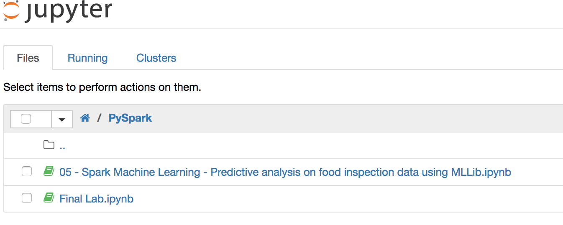

### Open [Spark Machine Learning - Predictive analysis on food inspection data using MLLib.ipynb](https://pranavsparkbuildlab.azurehdinsight.net/jupyter/notebooks/PySpark/05%20-%20Spark%20Machine%20Learning%20-%20Predictive%20analysis%20on%20food%20inspection%20data%20using%20MLLib.ipynb)

This is a sample notebook which will walk you through the steps of interacting with a notebook, basics of machine learning of Spark. You will apply these learnings in a new notebook to predict book sales

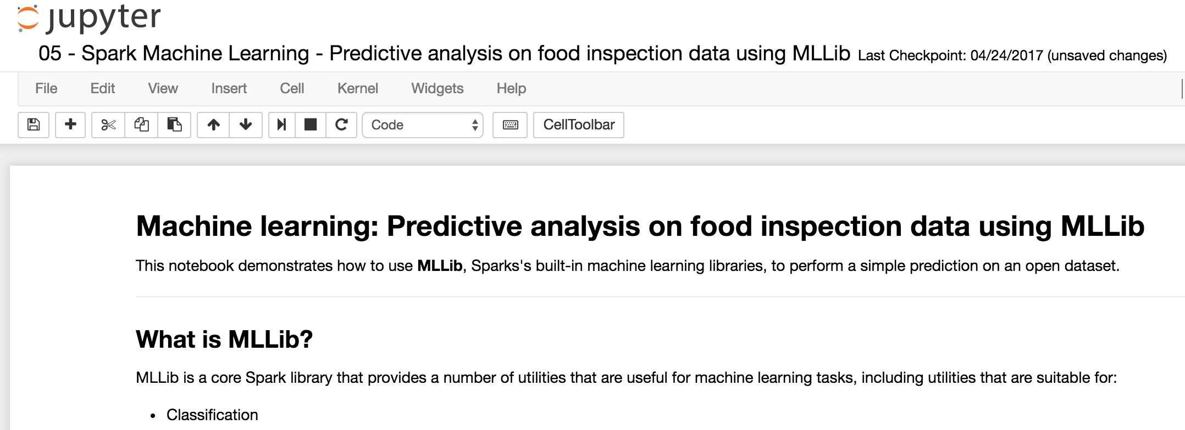

### Notebook Setup

* Read the opening paragraph to understand about the scenario and the model to apply.
* Run through all the steps in the notebook.
* To run the cells below, place the cursor in the cell and then press **SHIFT + ENTER**.

### Initializing Spark - Construct an Input DataFrame

Read the dataset from a csv file stored in Azure Blob Storage.

inspections = spark.read.csv('wasb:///HdiSamples/HdiSamples/FoodInspectionData/Food_Inspections1.csv', inferSchema=True)

#### Inspect Schema

inspections.printSchema()

#### See a detailed record

df.take(1)

#### Understand the dataset

* + Let's start to get a sense of what our dataset contains. For example, what are the different values in the `results` column?

df.select('results').distinct().show()

#### A visualization can help us reason about the distribution of these outcomes.

%%local

%matplotlib inline

import matplotlib.pyplot as plt

labels = count_results_df['results']

sizes = count_results_df['cnt']

colors = ['turquoise', 'seagreen', 'mediumslateblue', 'palegreen', 'coral']

plt.pie(sizes, labels=labels, autopct='%1.1f%%', colors=colors)

plt.axis('equal')

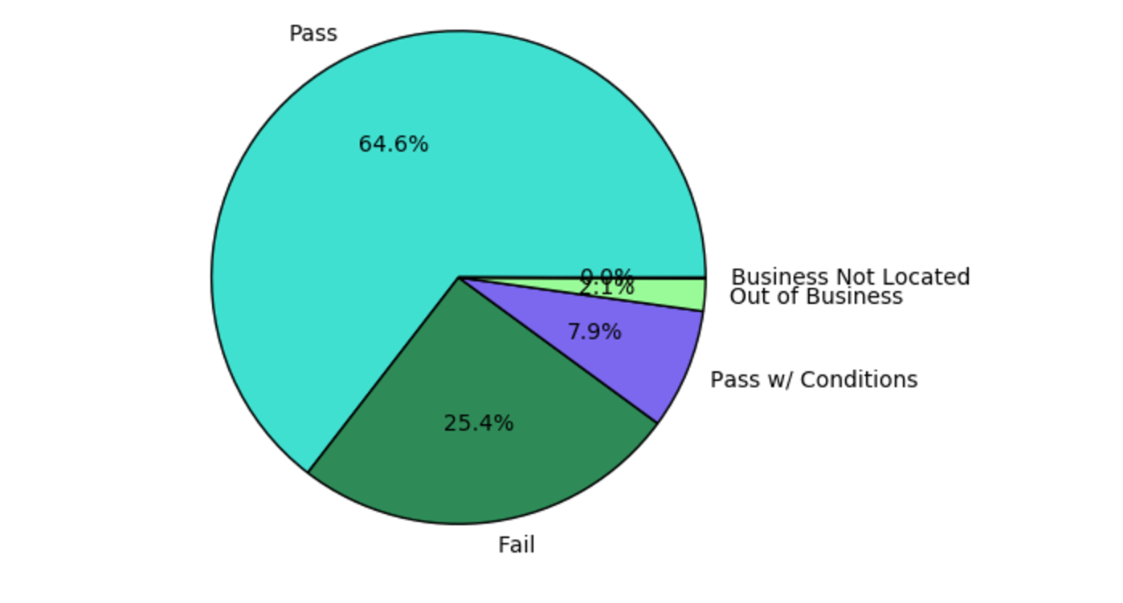

### Create a logistic regression model from the input dataframe

This will allow you to categorize the data which you can use to predict the outcome in the next step

### Evaluate the model on a separate test dataset

We can use the model we created earlier to predict what the results of new inspections will be, based on the violations that were observed.

testData = selectInterestingColumns(spark.read.csv('wasb:///HdiSamples/HdiSamples/FoodInspectionData/Food_Inspections2.csv', inferSchema=True))

testDf = testData.where("results = 'Fail' OR results = 'Pass' OR results = 'Pass w/ Conditions'")

predictionsDf = model.transform(testDf)

predictionsDf.registerTempTable('Predictions')

predictionsDf.columns

#### Look at the success rate.

numSuccesses = predictionsDf.where("""(prediction = 0 AND results = 'Fail') OR

(prediction = 1 AND (results = 'Pass' OR

results = 'Pass w/ Conditions'))""").count()

numInspections = predictionsDf.count()

print("There were %d inspections and there were %d successful predictions" % (numInspections, numSuccesses))

print("This is a %d%% success rate" % (float(numSuccesses) / float(numInspections) * 100))

#### Final visualization to help us reason about the results of this test.

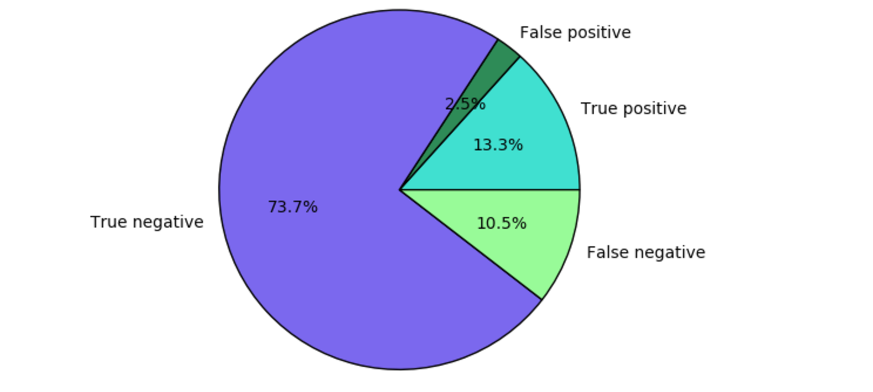

## Scenario 2 – Apply the basics of machine learning to predict book sales.

In this scenario, you will apply your learnings from Scenario 1.

**Scenario**: This notebook demonstrates how to use MLLib, Spark's built-in machine learning libraries, to perform a simple predictive analysis on an open dataset.

Launch Jupyter Notebooks https://<Fill_ME_IN>.azurehdinsight.net/jupyter/tree/PySpark

* + Username: <FILL_ME_IN>
  + Password: <FILL_ME_IN>



### Open Final Lab.ipynb

This is the same notebook you learnt in Scenario 1. In this notebook, you will apply the learnings to a different dataset.

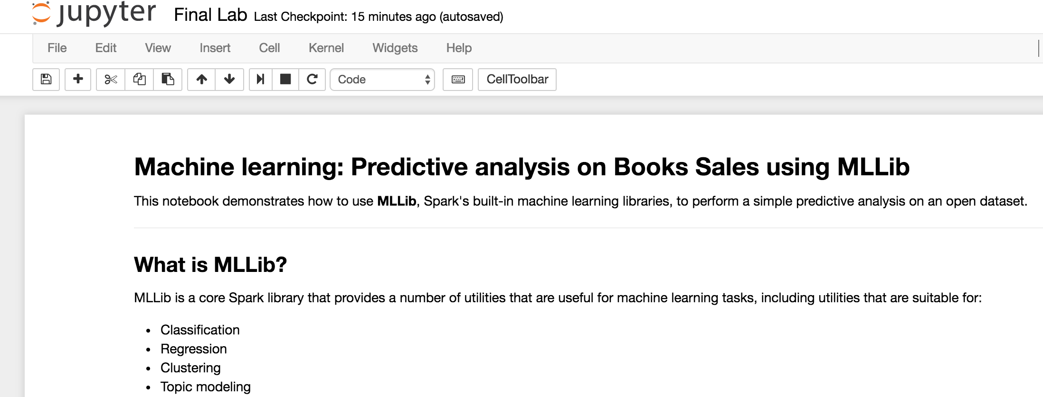

### Notebook Setup

* Read the opening paragraph to understand about the scenario and the model to apply.
* Run through all the steps in the notebook.
* To run the cells below, place the cursor in the cell and then press **SHIFT + ENTER**.

### Initializing Spark - Construct an Input DataFrame

Read the dataset along with headers from a csv file stored in Azure Blob Storage.

* Replace **<FILL_ME_IN_WITH_header=True>** with **header=True** in the following statement

inspections = spark.read.csv('/sparklabs/Lab03/SaleTransactions1.csv', inferSchema=True, **<FILL_ME_IN_WITH_header=True>**)

#### Inspect Schema

inspections.printSchema()

#### See a detailed record

df.take(1)

### Understand the dataset

Let's start to get a sense of what our dataset contains. For example, what are the different values in the `**CustomerAction**` column?

* Replace **<FILL_ME_IN_WITH_ColName>** with **CustomerAction**

inspections.select('**<FILL_ME_IN_WITH_ColName>**').distinct().show()

#### A visualization can help us reason about the distribution of these outcomes.

* Replace **<FILL_ME_IN_WITH_ColName**> with **CustomAction**

%%local

%matplotlib inline

import matplotlib.pyplot as plt

labels = count_results_df['**<FILL_ME_IN_WITH_ColName>**']

sizes = count_results_df['cnt']

colors = ['turquoise', 'seagreen', 'mediumslateblue', 'palegreen', 'coral']

plt.pie(sizes, labels=labels, autopct='%1.1f%%', colors=colors)

plt.axis('equal')

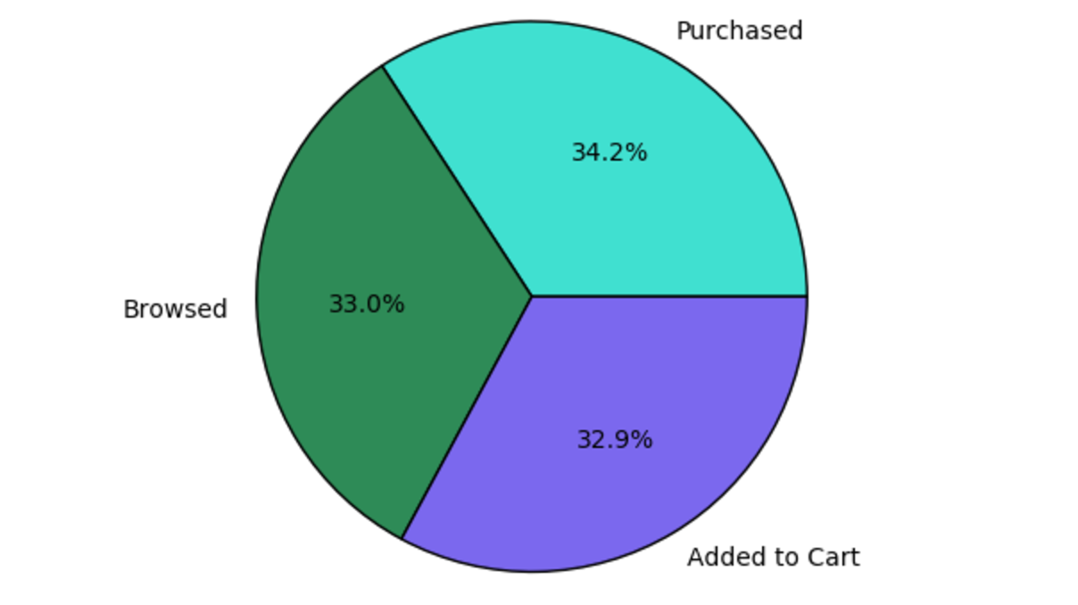

Let us develop a model that can guess the outcome whether a book is purchased based on customer action. From the previous visualization, a **CustomerAction** could be one of the following :- ‘**Purchased’**, **‘Added To Cart’** or **‘Browsed’**

Since logistic regression is a binary classification method, it makes sense to group our data into two categories: **Purchased** and **Not purchased**. A "Added To Cart" is not a purchase, so when we train the model, we will consider the two results equivalent.

* + - Replace **<FILL_ME_IN>** with the **highlighted**

def labelForResults(s):

if s == **'Purchased'**:

return 1.0

elif s == **'Added To Cart'** or s == **'Browsed'**:

return 0.0

else:

return -1.0

label = UserDefinedFunction(labelForResults, DoubleType())

labeledData = inspections.select(label(inspections.CustomerAction).alias('label'), inspections.Name ).where('label >= 0')

### Create a logistic regression model from the input dataframe

This will allow you to categorize the data which you can use to predict the outcome in the next step

### Evaluate the model on a separate test dataset

We can use the model we created earlier to predict what the results of new inspections will be, based on the violations that were observed.

testData = spark.read.csv('/sparklabs/Lab03/SaleTransactions2.csv', inferSchema=True, header=True)

testDf = testData.where("CustomerAction = **'Purchased'** OR CustomerAction = **'Added To Cart'** OR CustomerAction = **'Browsed'**")

predictionsDf = model.transform(testDf)

predictionsDf.registerTempTable('Predictions')

predictionsDf.columns

#### Look at the success rate.

* Replace **<FILL_ME_IN>** with the **highlighted**

numSuccesses = predictionsDf.where("""(prediction = 1 AND CustomerAction = **'Purchased'**) OR

(prediction = 0 AND (CustomerAction = **'Added To Cart'** OR

CustomerAction = **'Browsed'**))""").count()

numInspections = predictionsDf.count()

print("There were %d User sessions and there were %d successful predictions" % (numInspections, numSuccesses))

print("This is a %d%% success rate" % (float(numSuccesses) / float(numInspections) * 100))

#### Final visualization to help us reason about the results of this test.



# Learn more and get help

* [Azure HDInsight Overview](https://azure.microsoft.com/en-us/services/hdinsight/)
* [Getting started with Azure HDInsight](https://docs.microsoft.com/en-us/azure/hdinsight/)
* [Use Hive on HDInsight](https://docs.microsoft.com/en-us/azure/hdinsight/hdinsight-hadoop-linux-tutorial-get-started)
* [Use Spark on HDInsight](https://docs.microsoft.com/en-us/azure/hdinsight/hdinsight-apache-spark-overview)
* [Use Interactive Hive on HDInsight](https://docs.microsoft.com/en-us/azure/hdinsight/hdinsight-hadoop-use-interactive-hive)
* [Use HBase on HDInsight](https://docs.microsoft.com/en-us/azure/hdinsight/hdinsight-hbase-overview)
* [Use Kafka on HDInsight](https://docs.microsoft.com/en-us/azure/hdinsight/hdinsight-apache-kafka-introduction)
* [Use Storm on HDInsight](https://docs.microsoft.com/en-us/azure/hdinsight/hdinsight-storm-overview)
* [Use R Server on HDInsight](https://docs.microsoft.com/en-us/azure/hdinsight/hdinsight-hadoop-r-server-overview)
* [Open Source component guide on HDInsight](https://docs.microsoft.com/en-us/azure/hdinsight/hdinsight-component-versioning#hadoop-components-available-with-different-hdinsight-versions)
* [Extend your cluster to install open source components](https://docs.microsoft.com/en-us/azure/hdinsight/hdinsight-hadoop-customize-cluster-linux#support-for-open-source-software-used-on-hdinsight-clusters)
* [HDInsight release notes](https://docs.microsoft.com/en-us/azure/hdinsight/hdinsight-release-notes)
* [HDInsight versioning and support guidelines](https://docs.microsoft.com/en-us/azure/hdinsight/hdinsight-component-versioning#supported-hdinsight-versions)
* [How to upgrade HDInsight cluster to a new version](https://docs.microsoft.com/en-us/azure/hdinsight/hdinsight-upgrade-cluster)
* [Ask HDInsight questions on stackoverflow](https://stackoverflow.com/questions/tagged/hdinsight)
* [Ask HDInsight questions on Msdn forums](https://social.msdn.microsoft.com/forums/azure/en-us/home?forum=hdinsight)